User stories for hotel management system

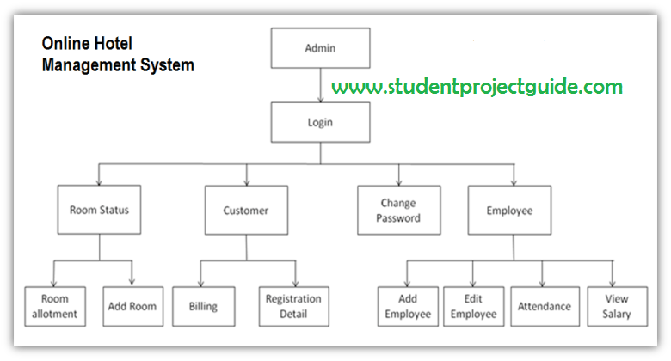

User story for Room allotment:

As a hotel receptionist, I want to be able to check the status of a room so that I can efficiently manage room assignments and reservations.

Acceptance Criteria:

* The system should display the current status of the room (available, occupied, dirty, under maintenance).
* The system should allow me to filter rooms by status.

Add room;

As a hotel receptionist, I want to check the current status and count of the room so that I can add new rooms as per availability of the customers.

Acceptance criteria:

* The system should display the current status of the room.
* The system should show the count of the available rooms.
* The system should allow me to add a room as per availability.
* The system should display the count of added rooms.

Billing:

1.As a hotel receptionist, I want to be able to view the final bill for the stay of a customer and the payment options, so that I can review the charges and make a payment.

2.As a hotel receptionist, I want a payment receipt should be sent to the customer after the payment, so that customer can receive a receipt via email.

Acceptance criteria:

* The system should display a clear breakdown of charges, including:
* Room rate
* Taxes
* Additional fees (e.g., resort fees, parking charges)
* The system should offer multiple secure payment options (e.g., credit card, debit card).
* The customer should receive a receipt via email or other preferred method.

Registration details:

As a hotel receptionist, I want to be able to view the registration page, so that the registration details can be filled for a customer.

Acceptance criteria:

* The system should have a registration link in the dashboard.
* The receptionist should be able to enter the guest's name, contact information (phone number and email address), and address.
* The system should validate the entered information to ensure accuracy.
* The receptionist should be able to select the guest's nationality and country of residence from a list.
* The system should automatically generate a unique guest ID number.
* The receptionist should be able to save the guest's details and link them to the existing reservation.